11.Container with Most Water

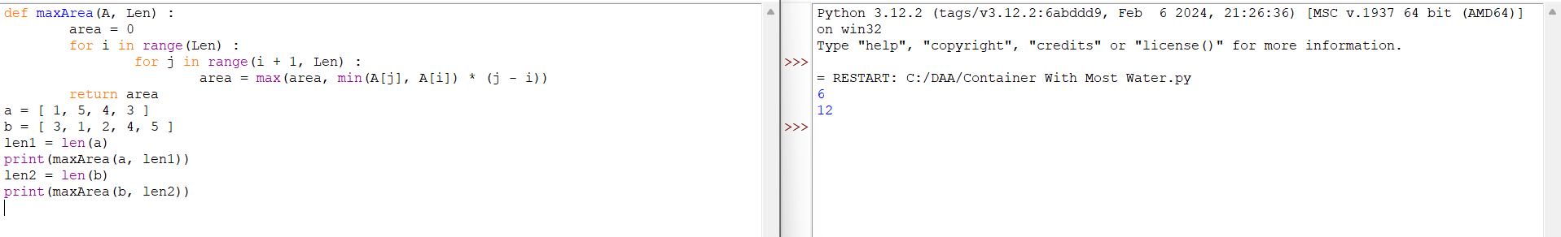

12.Integer to Roman

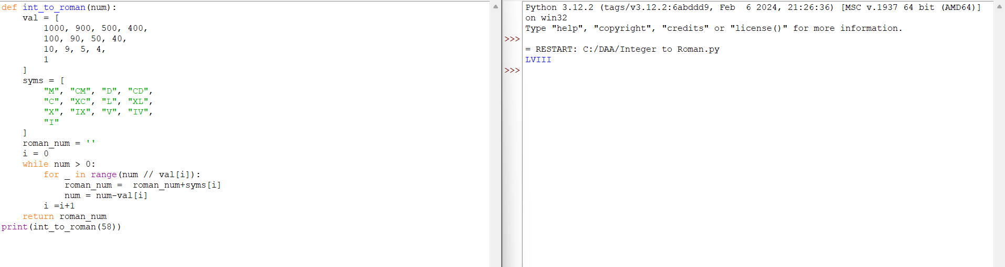

13.Roman to Integer

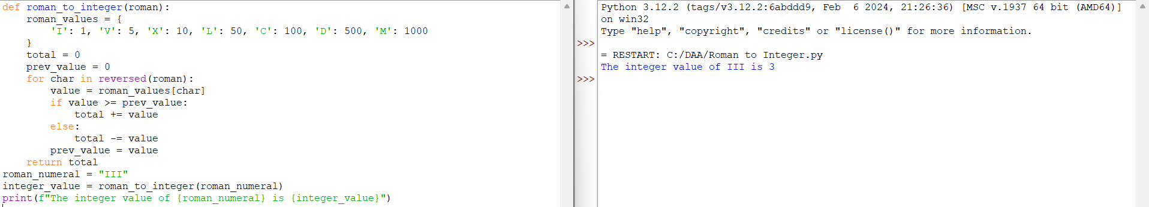

14.Longest Common Prefix

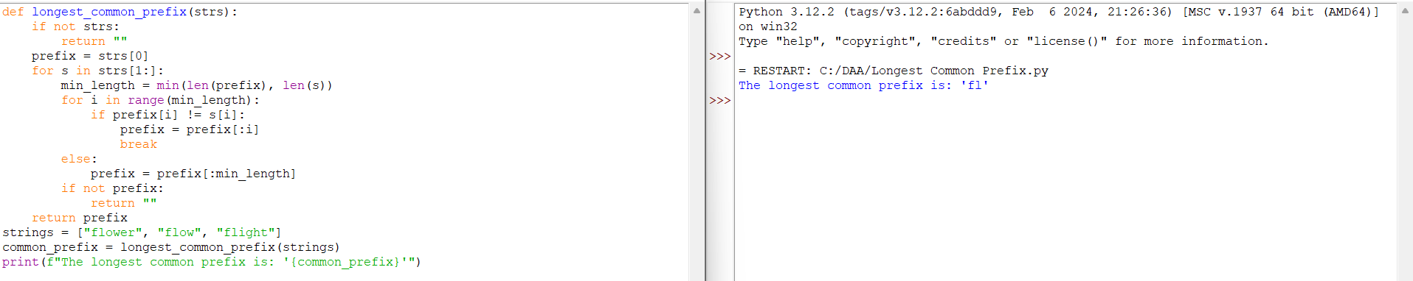

15.3Sum

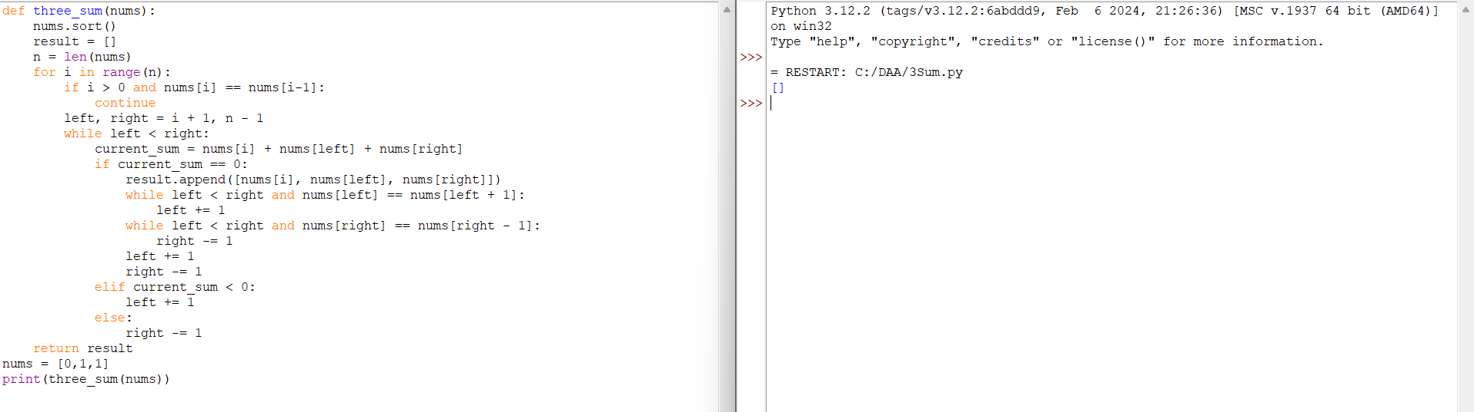

16.3Sum Closest

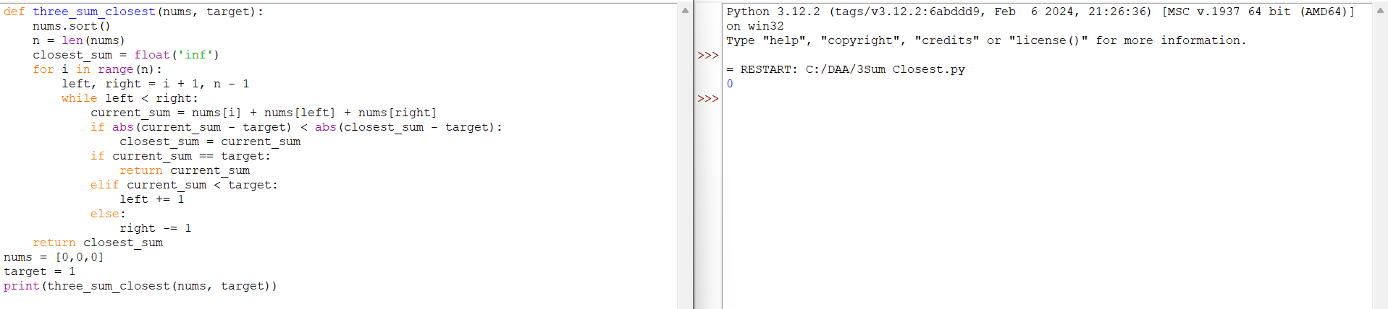

17.Letter Combinations of a phone Number

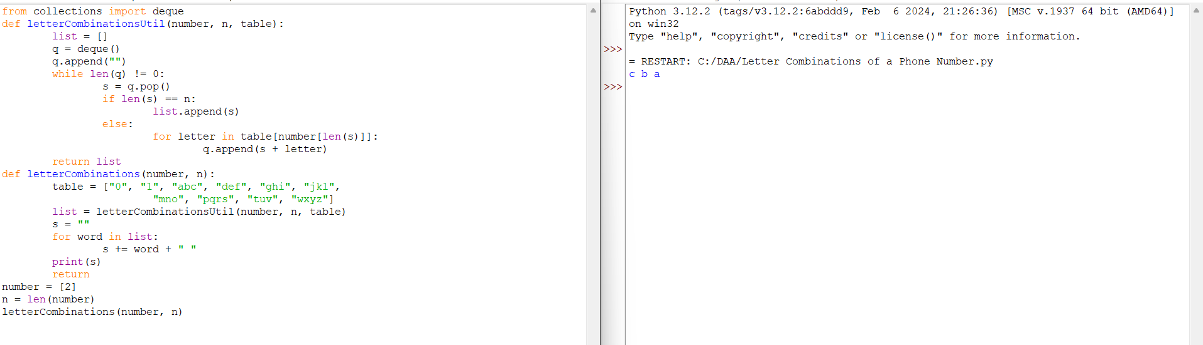

18.4Sum

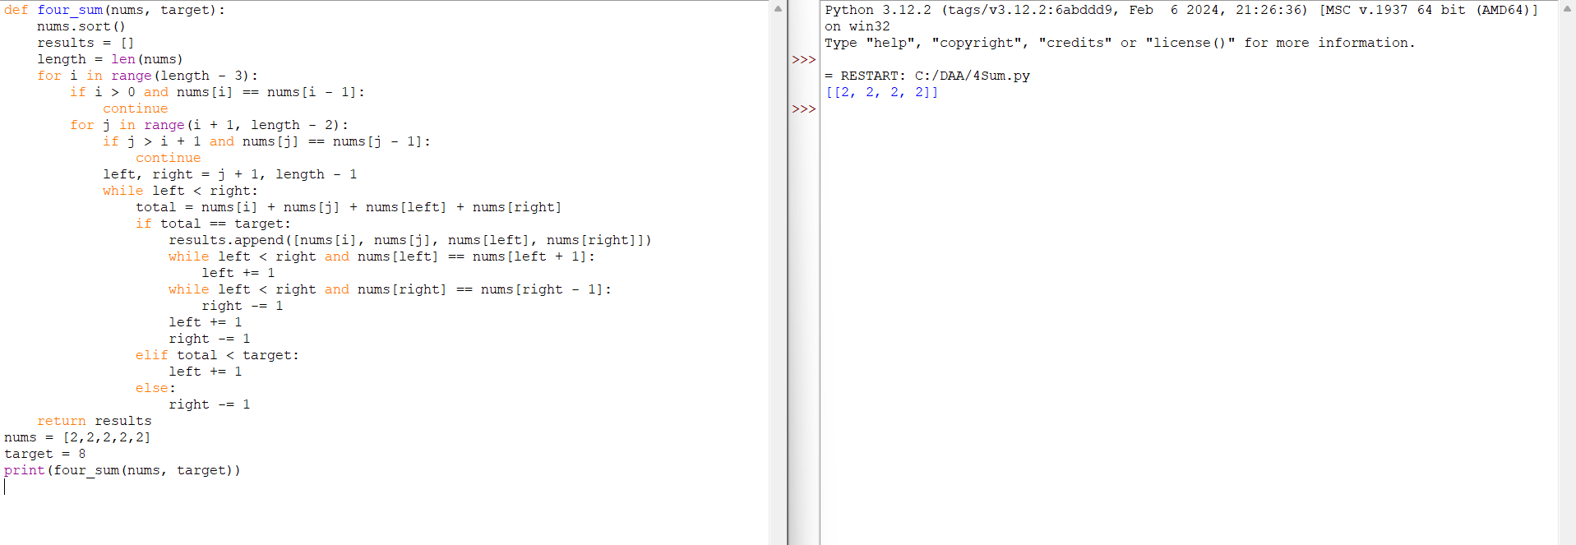

19.Remove Nth Node from End of List

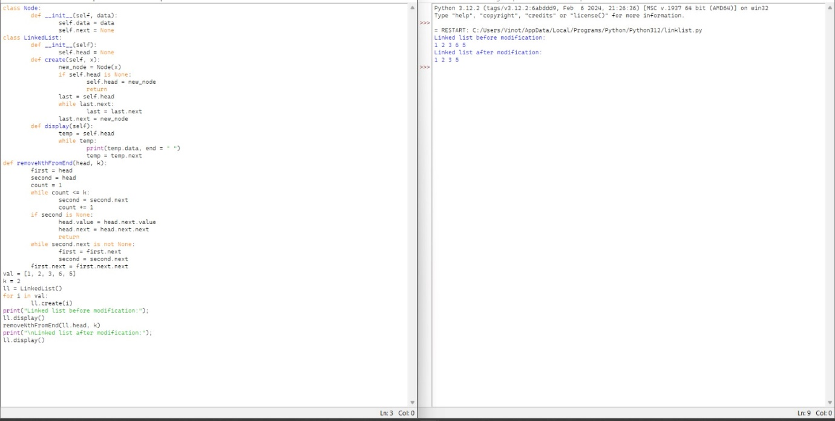

20.Valid Parentheses

